Terms of Reference for Blackcurrant Field Development Working Group

The Parish Council as the parent body can form a Working Group to carry out specific detailed tasks on any matter that falls within its powers.

1. Membership
Members of the working party will be appointed by the Parish Council and will consist of at least one member of the council but may also co-opt up members of the public (Lay members) who have specific knowledge / expertise on the subject to assist the Working Group.

The Term of Membership for a working group will be for a period of one year or to the next Annual meeting of the Full Council or time limited for a period of 6 months.

The Annual Meeting of the Council can re-confirm the working group’s membership and terms of reference or appoint other elected members to serve for the forthcoming civic year.

2. Leader
A leader will be appointed for the working party by the Parish Council. In this case it is Stuart Arnold. The leader will be the main point of contact for the Clerk to Council, Council members and members of the public, and must be a member of the Council unless otherwise agreed by the Full Council.

3. Powers
Working Groups cannot make decisions or spend any money on behalf of the Parish Council, and any recommendations made by working parties will be subject to approval by the Full Council.

4. Responsibilities and Areas of Operation
The Full Council will establish the role of the working group and its terms of reference.
The Blackcurrant Field Development Working Group organisation structure is described in the image on the following page.

The working group will arrange its own meetings and schedule of work at its inaugural meeting.
The leader of the working group, if unable to attend a meeting of the Full Council, will nominate
another member of the working party to attend and deliver the progress report.
The Blackcurrant Field Development working group will discuss how best to gather information, communicate with parishioners and campaign for the best outcome for the parish regarding any development, residential or otherwise, on the Blackcurrant Field

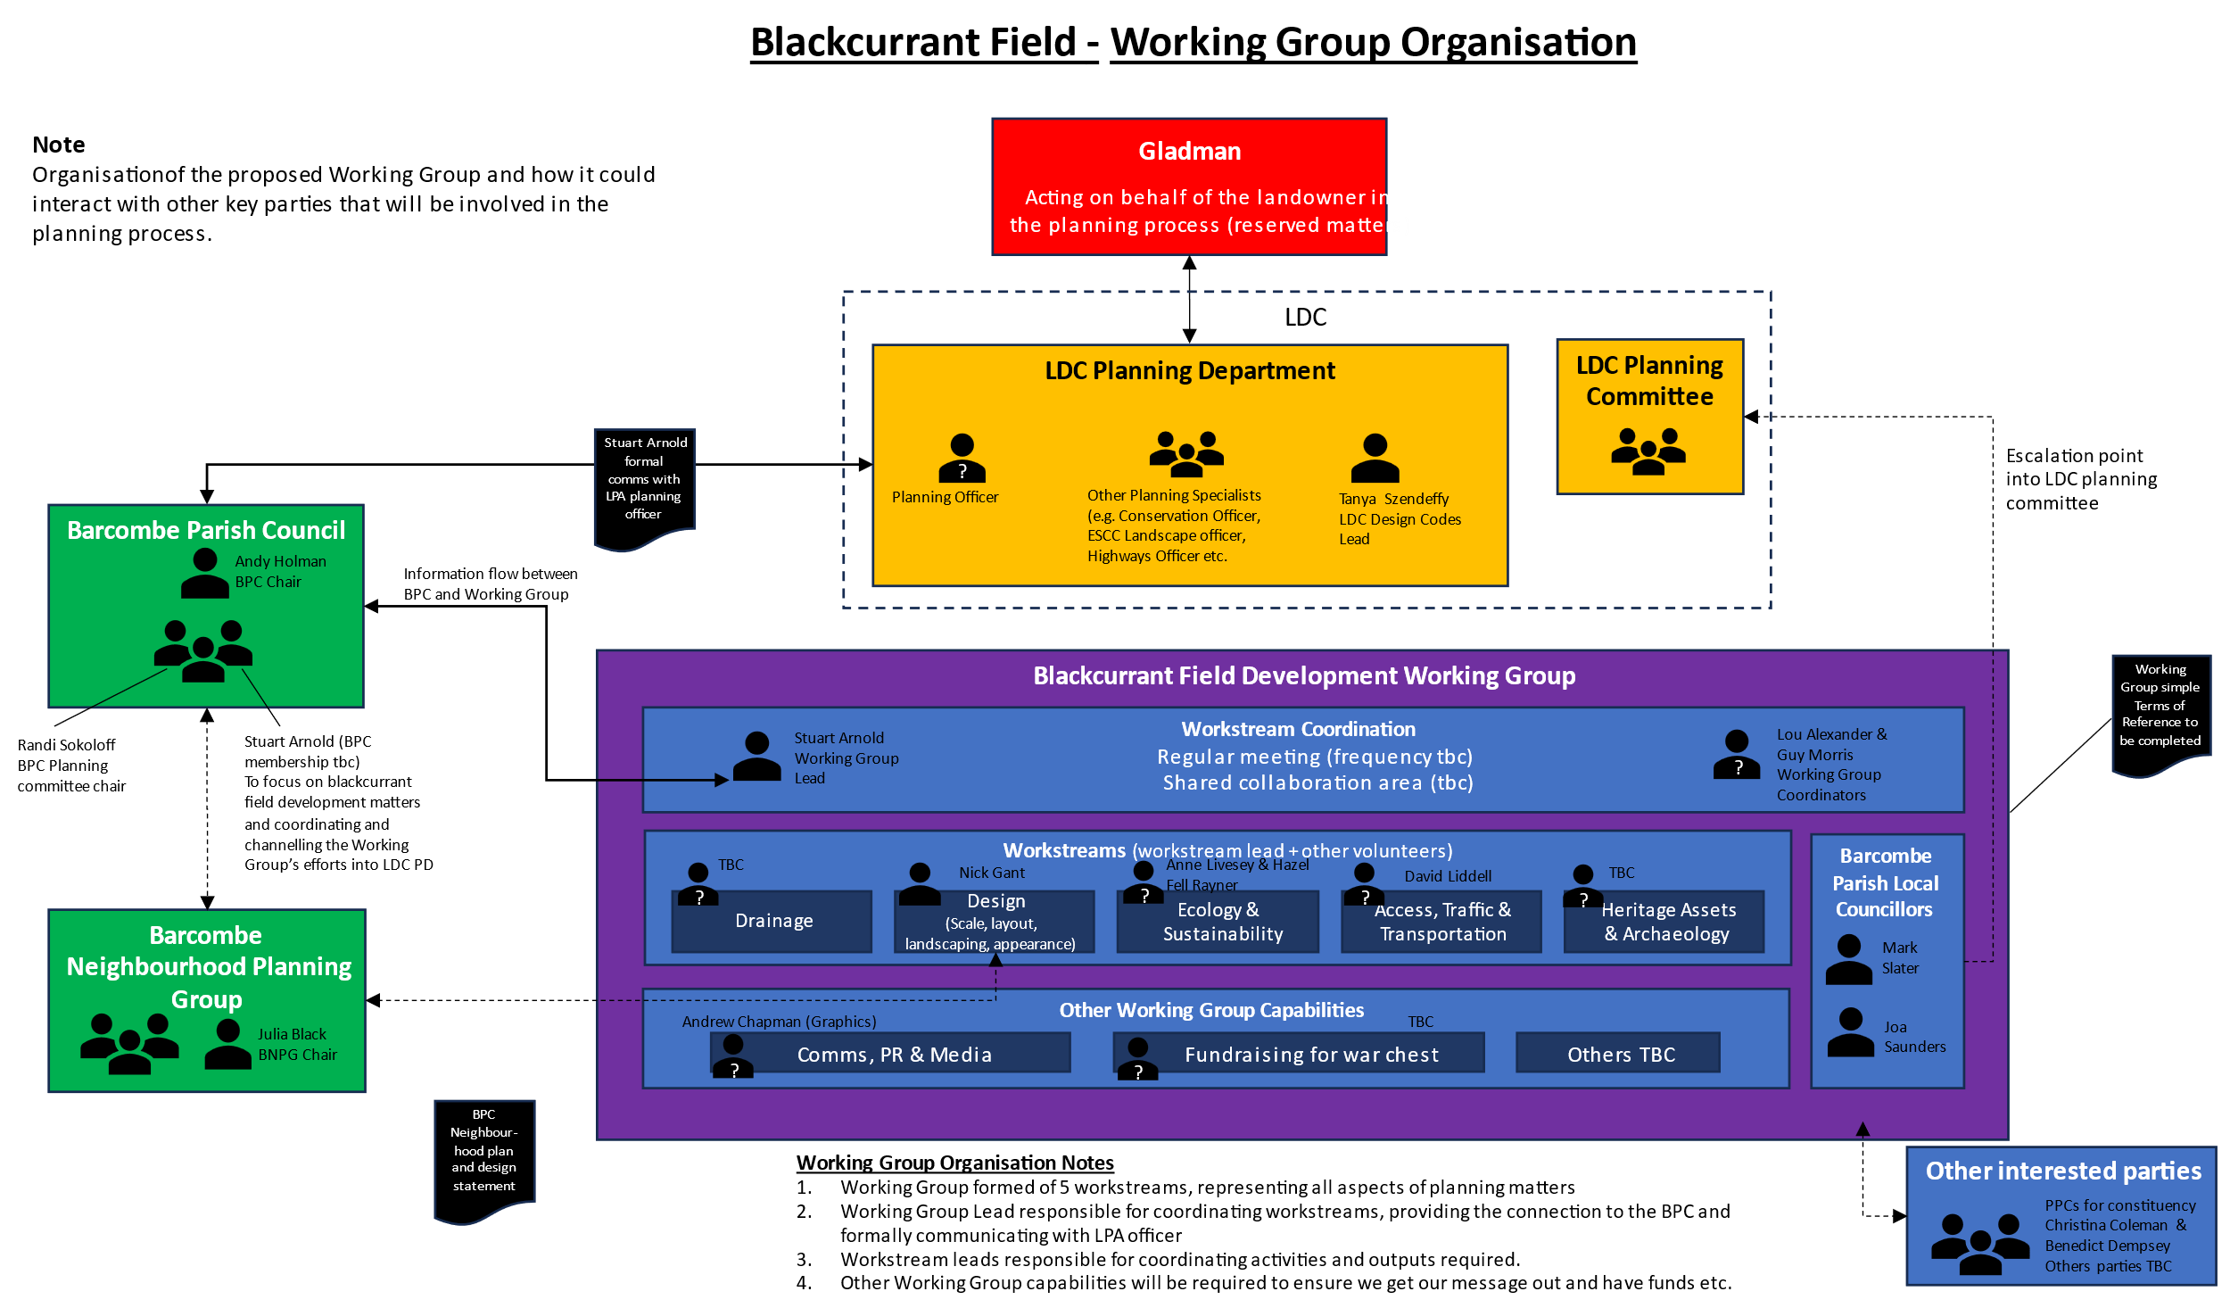

5. Meetings of Working Groups
Meetings of the working group will be held in a publicly advertised location which may be Barcombe Sports Pavilion, a local hall or a private residence.

The Clerk to the Council will be notified of any meeting with at least 4 working days’ notice and will advertise the meeting with at least 3 working days notice.

The quorum of the group shall be one Parish Councillor member of the group plus two other members.

The working group shall report formally to each meeting of the Full Council if necessary. Additional informal updates to Council members will be circulated following each meeting of the Blackcurrant Field Development Working Group.

The working group will report formally to the Full Council at its Annual Meeting if requested.

6. Frequency of Meetings (as required).
The working group is expected to be time limited. The continuing need for a working group will be reviewed by the Full Council on an annual basis.

